W E E K 4 T A S K

Exploratory Data Analysis and Feature Engineering
Real Sephora skincare reviews: facewashes, acne-focused serums and a spot patch

Submitted by: Vishakha Bisht
Data Science with Python Analyst Internship in Coimbatore

Contents
- Summary and Key Findings
- Data Used
- EDA Workflow, Statistical Methods and Visualisation Plan
- EDA Results
- Feature Engineering
- Do the Features Improve Model Accuracy?
- Hypothetical Business Scenario
- Limitations and Next Steps References
Appendix: Synthetic-data check, files and environment

Summary and Key Findings
Weeks 1 to 3 defined the problem (why do skincare customers write negative reviews?), planned the data and built a cleaning pipeline on simulated data. This week the analysis runs on real data: 140,435 public Sephora reviews of 98 products (2008-08-28 to 2023-03-21). The data is explored with statistics and charts, 49 features are engineered, and their effect on a prediction model is measured. Every number comes from real_eda.py (appendix).

Finding | Evidence (real data) | Why it matters
Ratings are very skewed, so the mean hides the story | 5 stars: 63.2%; 1 to 2 stars: 9.8%. Mean 4.31,  median 5, skewness -1.69 | Use rank-based tests and study the low-rating tail
The one patch product is rated far lower than serums and facewashes | Mean 3.04 (n=579) vs 4.31 serum and 4.31 facewash. 41% of its reviews are 1 to 2 stars vs 9% (serum). Kruskal-Wallis p < 0.001 | Large effect (rank-biserial about  −0.45), but based on a single product
Reasons for dissatisfaction depend on product type | Chi-square = 598.1, p < 0.001, Cramer’s V =  0.15. Facewash: 43.1% irritation or smell; patch: 43.2% "did not work" | Facewash problems are tolerance problems; patch problems are efficacy problems (H3 supported)
Misapplication on deep lesions is NOT a main driver for this patch | Only 7.2% of low-rated patch reviews mention deep or cystic lesions (95% CI 4.2% to 10.6%), below the 15% threshold | H2 is not supported on real data; the synthetic result in Week 3 does not carry over
Sensitive-skin reviewers report irritation far more often | 34.1% of reviews that mention "sensitive" describe irritation vs 13.2% of others (n=18,088) | Supports the sensitive-skin focus; H1 cannot be tested properly (only 20 sensitive patch reviews)
Fragrance in the ingredient list does NOT raise irritation here | Irritation reported in 14.7% of reviews of fragranced products (49 products) vs 17.0% for fragrance-free (49); adjusted odds ratio 0.87  (95% CI 0.70 to 1.10) | H4 is not supported; actives such as retinoids look like the bigger irritation driver
Customer words matter more than product facts | Cross-validated AUC for predicting 1 to 2 star reviews: 0.514 (raw structured) → 0.711 (engineered structured) → 0.888 (plus text features) | Engineered features help clearly on real data (Section 6)

Scope note. The two review files supplied hold 302 products; after keeping facewashes, serums and patches by product name, 98 products remain, and only one of them is a patch ("Focuspot Micro Tip Patches", 579 reviews, all in one file). The patch findings therefore describe one product, not the whole patch category. The product table (product_info.csv) supplies ingredients and categories for all 98 products, so H4 (fragrance) is tested on the ingredient list. The data still has no "sensitive" skin-type option, so H1 is tested through review text only, and H5 (re-ranking) could not be tested because there is only one patch product.

Data Used

Item | Detail
Source | Sephora Products and Skincare Reviews (Kaggle): two review files, reviews_500-750.csv (full) and reviews_0-250_small.csv (rows already limited to patch, serum, cleanser, wash and essence products), 19 columns; together 247,289 reviews of 302 products
Product table | product_info.csv (8,494 products, 27 columns): ingredient list, categories and popularity (loves) joined on product_id; ingredients are present for all 98 products

Item | Detail
Selection | Product type taken from the product name (patch, serum/essence, cleanser/wash); the category column broadly agrees (76% of facewash reviews are in "Face Wash & Cleansers", 81% of serum reviews in "Face Serums"; the rest are exfoliating cleansers, essences and serum-moisturiser hybrids, and the patch is listed under Face Serums). Eye patches, masks, wipes, oils, toners and moisturisers were excluded. Exact duplicate reviews were dropped
Final sample | 140,435 reviews, 98 products: serum 76,204 (60 products), facewash 63,652 (37),  patch 579 (1)
Skin type (as stated by reviewer) | combination 72,656, dry 22,950, normal 16,605, oily 16,541, unknown 11,683
Missing values | helpfulness 54.6%, recommended flag 16.1%, skin type 8.3%, review text 0%, price  0%
Train/test split | 111,209 train and 29,226 test reviews, split by product so no product appears in both
Labels | None are given. Reasons for dissatisfaction come from negation-aware keyword rules (for example "no irritation" is not counted as irritation). The prediction target is "rated 1 to 2 stars" (9.8% of reviews)

EDA Workflow, Statistical Methods and Visualisation Plan

Workflow (every step was run)

# | Question | Method | Library | Section
1 | What is missing and how are values distributed? | isna, describe, skewness, IQR fences, histograms | pandas, SciPy | 4.1
2 | Do ratings differ by product type? | Kruskal-Wallis; pairwise Mann-Whitney with Bonferroni; rank-biserial effect size (ratings are ordinal and skewed, so no t-test) | SciPy | 4.2
3 | Does the reason for a low rating depend on product type (H3)? | Chi-square, Cramer’s V, standardised residuals | SciPy | 4.3
4 | Do low-rated patch reviews describe deep lesions (H2)? | Proportion with bootstrap CI against the 15% threshold | NumPy | 4.4
5 | Sensitive skin and irritation (H1); fragrance in ingredients (H4) | Rate comparison, Fisher/chi-square, logistic odds ratio with product-level bootstrap CI | SciPy, scikit-learn | 4.5
6 | Is the star rating consistent with the recommend flag? | Spearman correlation, conflict counts | SciPy | 4.6
7 | Is there a time trend? | Yearly counts and mean rating, Spearman trend test | pandas, SciPy | 4.6
8 | Which variables move together? | Spearman correlation matrix | seaborn | 4.7
9 | What do unhappy customers say? | Uni- and bi-gram counts on 1 to 2 star reviews, negations kept | scikit-learn | 4.7

Visualisation choices

Question | Chart | Reason
Shape of one variable | Histogram or bar with labels | Shows skew that a mean hides
Rating mix across product types | Grouped bars of % within type | Types differ in size, so counts would mislead
Price by type | Box plot | Compares spread and median

Question | Chart | Reason
Reason mix per product type | 100% stacked horizontal bar, labelled | Compares shares across groups of different size
Many variables at once | Lower-triangle correlation heatmap, blue-grey-red | Diverging colour with grey at zero shows direction
Effect of a transformation | Raw and log histograms with skewness in the title | Makes the benefit of the transform visible
Model comparison | Bars with fold-to-fold error bars | Shows whether a gain is larger than the noise
Charts use matplotlib and seaborn. Colours: blue, orange and green for categories (chosen to stay distinguishable for colour-blind readers); a blue-red diverging scale for correlations.

Advanced techniques for the full data (planned)

Technique | Use in this project
PCA or UMAP on scaled features, then a scatter | See whether complaint types separate in feature space
k-means or hierarchical clustering of products | Group products by complaint profile (irritation-prone, efficacy-doubted)
Mutual information | Rank features against the 1 to 2 star label, including non-linear effects
Topic modelling (LDA, BERTopic) on low-rated reviews | Find complaint themes beyond the keyword rules
SHAP or partial dependence on the final model | Explain how each feature changes predictions
Benjamini-Hochberg correction | Control false discoveries when many hypotheses are tested (Benjamini & Hochberg, 1995)

EDA Results

Data quality and distributions
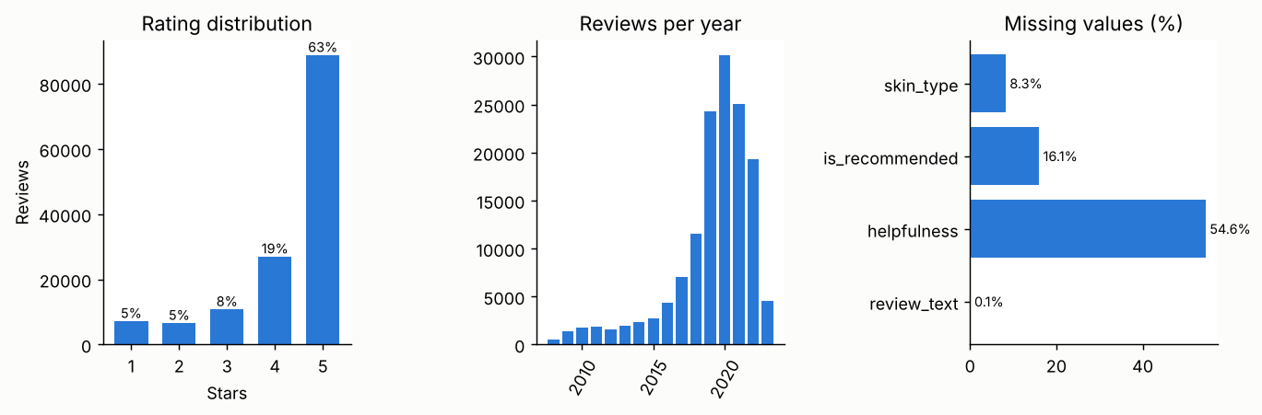
Figure 1. Rating distribution, reviews per year and missing values
    - Rating: median 5, mean 4.31, skewness -1.69; 63.2% are 5 stars.
    - Price (USD): median 40.00, mean 55.74, range 8.90 to 425.00, skewness 3.30.
    - Review length: median 49 words, maximum 828, skewness 2.24; 1744 reviews lie beyond 3 × IQR (kept, because long reviews are genuine).

    - Helpful votes: median 0, mean 3.74, maximum 1982, skewness 44.09 (extreme). The "helpfulness" ratio is missing for 54.6% of reviews, so it is not used.
    - Volume over time: reviews grow from 476 in 2008 to 19,280 in 2022. Mean rating moves between 4.24 (2020) and 4.37 (2008); the overall trend is negligible (Spearman ρ = -0.02, p < 0.001) and is significant only because n is large.

Ratings and prices by product type
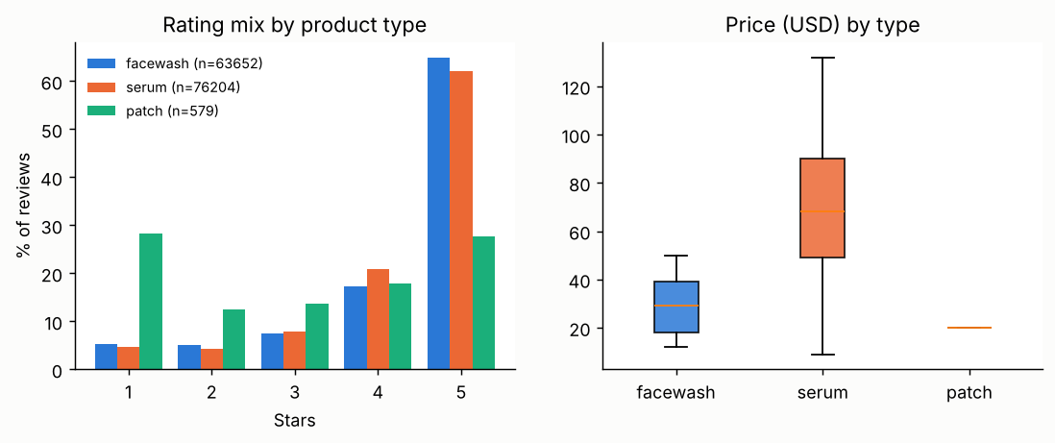
Figure 2. Rating mix and price by product type
Serums and facewashes are rated identically on average (4.31 and 4.31; difference 0.000 stars, rank-biserial -0.018). The Bonferroni p-value is small (p < 0.001) only because the sample is large; the effect is negligible and has no practical meaning. The patch is 1.27 stars lower than serums and 1.27 lower than facewashes (both p < 0.001), a large effect (rank-biserial about −0.45). Only 50% of patch reviewers recommend the product, against 86% (serum) and 83% (facewash). Mean prices are 20.00 (patch), 29.21 (facewash) and 78.18 (serum) USD.

Why reviews are negative (H3)
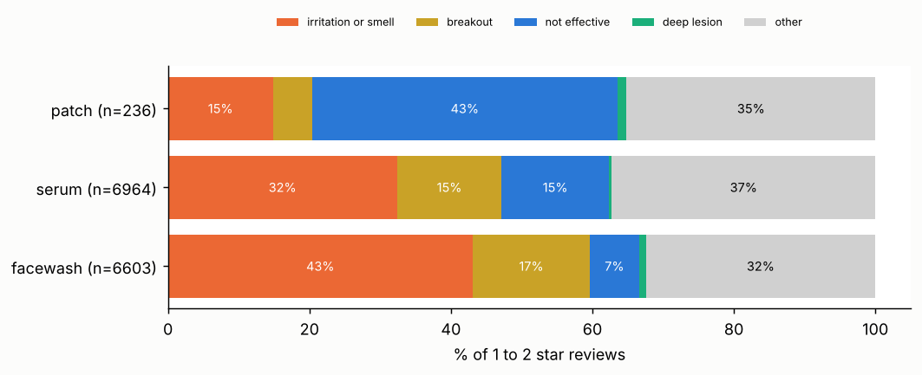
Figure 3. Reason mix in 1 to 2 star reviews, by product type (keyword rules)
The mix differs strongly by product type: chi-square = 598.1, df = 8, p < 0.001, Cramer’s V = 0.15 (small to moderate; with so many reviews even small differences are significant). Standardised

residuals show where: facewash irritation or smell +7.8 (43.1% of its low ratings), and patch "did not work" +14.2 (43.2%). Serums sit in between (32.4% irritation). H3 is supported, and the business reading is clear: cleansers lose customers through skin reaction, while the patch loses them because it does not deliver the promised result. About a third of low ratings in each type fall in "other" (short or vague text), a reminder that keyword rules are a first pass.

Deep lesions and misapplication on patches (H2)
Among the 236 low-rated patch reviews, 7.2% mention deep, cystic or hormonal lesions (bootstrap 95% CI 4.2% to 10.6%), against 3.5% in low-rated serum and facewash reviews. The Week 2 threshold was 15%, so H2 is not supported. The most frequent patch complaint terms point elsewhere: "not" (200), "dark" (115), "spot" (86), and the reviews describe patches that "did absolutely nothing" on dark spots. Reviews that mention deep lesions actually rate the patch higher (3.98 vs 2.82, p < 0.001, n=110). Caveat: the flag also catches phrases such as "deep wrinkles", so it overstates deep-acne mentions if anything. The lesson for the project is a useful one: a hypothesis taken from the clinical literature (hydrocolloid patches fail on cystic acne) did not appear in reviews of a micro-tip dark-spot patch. Reviewers’ problem is an expectation gap.

Sensitive skin and fragrance (H1 and H4)
    - Sensitive skin: the dataset has no "sensitive" skin-type option, so reviews that mention "sensitive" in the text were used (n=18,088). 34.1% of them describe irritation (burn, sting, redness, rash and similar) against 13.2% of other reviews, a rate 2.6 times higher. By type: serum 39.3% (n=7313), facewash 30.6% (n=10755), patch 60% (n=20).
    - H1 (patch vs serum for sensitive skin): the comparison is underpowered (only 20 patch reviews; Fisher p = 0.068, odds ratio 2.32 in the opposite direction to H1). H1 is not testable with this file.
    - Fragrance (H4), from the ingredient list: 49 of 98 products list a fragrance ingredient (parfum, fragrance, limonene, linalool and similar): facewash 65%, serum 42%, patch 0%. Raw rates go against H4: reviews of fragranced products mention irritation less often (14.7% vs 17.0%; chi-square = 137.8, p < 0.001; odds ratio 0.84). But reviews of one product are not independent, so a bootstrap over products is the honest test: after adjusting for product type and sensitive-skin mentions the odds ratio is 0.87 with a 95% CI of 0.70 to 1.10, which includes 1. At product level the difference is also borderline (mean irritation 14.3% for 48 fragranced vs 17.6% for 49 fragrance-free products, Mann-Whitney p = 0.052). Among sensitive-mention reviewers the two groups are almost the same (33.7% vs 34.6%). H4 is not supported: no evidence that fragranced products cause more irritation complaints.
    - Why? Probably active ingredients. Fragrance-free products are not automatically gentler: 27% of them contain salicylic acid, a retinoid or benzoyl peroxide, against 14% of fragranced products. Reviews of retinoid products (7 products, n=4,447) mention irritation 21.5% of the time vs 15.7% for the rest, and only 14% of them are fragranced. With 98 products this is a pattern to test, not proof, but it shows why one flag ("fragrance-free") is a weak stand-in for "gentle".

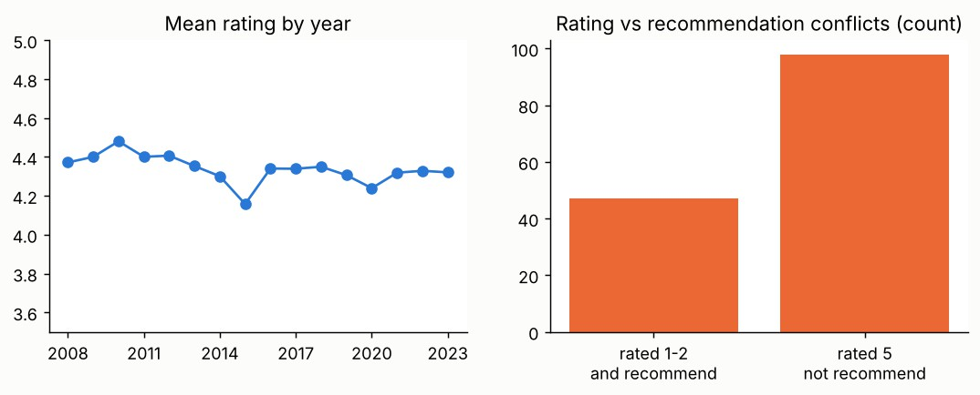
Figure 4. Mean rating by year, and reviews where rating and recommendation disagree
Stars and the "would recommend" flag agree strongly (Spearman ρ = 0.70): 99.9% of 5-star reviewers recommend, against 2.3% of 1 to 2 star reviewers. Only 98 five-star reviews say "not recommended" and 47 one-star reviews say "recommended", so rating is a reliable label and these 145 conflicts are candidates for manual checking.

4.7 Correlations and complaint vocabulary
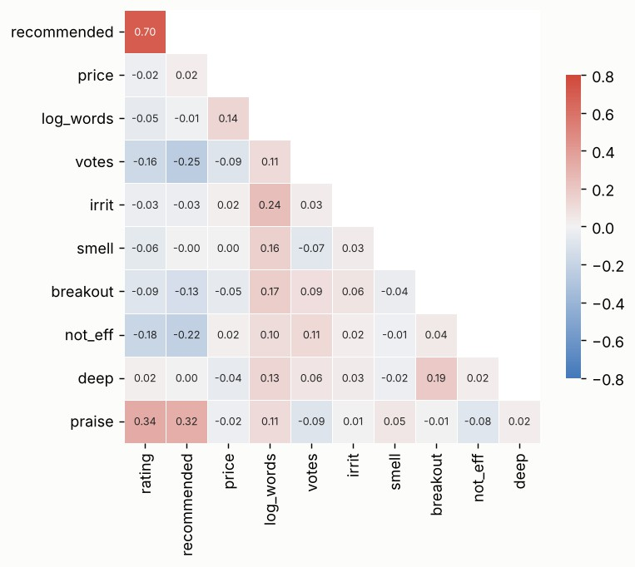
Figure 5. Spearman correlations (blue = negative, red = positive)
- Rating and the recommend flag are the strongest pair (ρ = 0.70). Praise words correlate with rating (0.34) and with recommendation (0.32).
- Votes, price and review length have weak correlations with rating (below 0.25 in absolute value), so they add little on their own and matter mainly in combination.

- Keyword flags for irritation, smell and breakouts are rare and weakly correlated with the rating (below 0.25), which is why combining them (Section 5) matters more than using any single one.
Most frequent terms in 1 to 2 star reviews (stop-words removed, negations kept): facewash "skin" (8,956), "not" (5,451), "dry" (2,381); serum "skin" (8,224), "not" (6,132), "didn" (2,203); patch "not" (200), "patches" (129), "dark" (115). The word "not" ranks first or second everywhere, which is why a plain bag-of-words without negation handling would misread these reviews.

Feature Engineering
The pipeline builds 49 features in real_eda.py. Three rules apply: (1) every feature must capture customer behaviour or market position that a raw column does not; (2) means and standard deviations are learned on training rows only, to avoid leakage (Kaufman et al., 2012); (3) the star rating and recommend flag are never used as inputs, because the target is derived from the rating.

Feature catalogue

Group | Features | How built and what it captures
Encoding | type_patch/serum/facewash; skin_combination/dry/normal/oily/unknown; price_tier | One-hot encoding for unordered categories; price_tier is ordinal (0 low, 1 mid, 2 high within the product type)
Log transform | log_price, log_words, log_title_len, log_votes_given | Reduce skew: price 3.30 to 0.12, length 2.24 to - 0.43, votes 44.09 to 1.37
Normalisation | price_z_in_type | Z-score of log price within product type, with training mean and SD: shows whether a product is premium for its own category (training means check to 0.000)
Scaling | StandardScaler inside the logistic pipeline | Fitted on training rows only
Missing indicators | skin_missing, text_missing | Missingness can itself be informative (reviewers who skip skin type may be less engaged)
Interactions | sens_x_nonpatch, oily_x_serum, patch_x_deep, sens_x_smell | Effects that exist only in a combination, such as sensitive-skin reviewers using serums and washes
Text sentiment | pos_count, neg_count, sentiment_score, negation_count | Negation-aware word-list sentiment: "not good" counts as negative, "no irritation" as positive
Keyword flags | flag_irrit, flag_smell, flag_breakout, flag_not_eff, flag_deep, flag_praise, flag_sensitive_mention | Complaint themes from Section 4, as 0/1
Writing style | n_exclaim, caps_ratio, has_words_ge_100 | Intensity and effort: exclamation marks and capital letters mark strong emotion
Ingredients (from product_info) | fragranced, fragrance_unknown, n_ingredients, act_salicylic/niacinamide/retinoid/vitc/bpo/hyaluronic, sens_x_fragranced, log_loves | Fragrance flag by regex on the ingredient text, formula length, active-ingredient flags, and product popularity (loves)
Time | month_sin, month_cos, days_since_start | Cyclical encoding puts December next to January; days since start captures trend
Product level | log_product_reviews | Popularity of the product (review count only, no labels)

Worked examples (real code from the script)
Example 1: normalisation within product type. A 20-dollar item is cheap for a serum (median 40.00 overall, mean serum price 78.18) but average for a patch. Standardising log price within each type, with statistics from training rows only, expresses this. The training means of the new feature are
0.000 for facewash and serum, as they should be (the single patch has one fixed price, so its z-score is set to 0).
stat = f[tr].assign(t=d.type[tr]).groupby('t')['log_price'].agg(['mean', 'std']) f['price_z_in_type'] = ((f.log_price - d.type.map(stat['mean'])) /
d.type.map(stat['std'])).fillna(0)
f['price_tier'] = pd.cut(f.price_z_in_type, [-np.inf, -.5, .5, np.inf], labels=[0, 1, 2]).astype(int)

Example 2: negation-aware sentiment. Skincare reviews are full of phrases like "did not irritate" and "no breakouts". A simple word counter would score these as negative. The function flips the polarity of a word that follows a negator.
def sent(ws):
p = n = 0
for i, w in enumerate(ws):
flip = i > 0 and ws[i - 1] in NEGATORS
if w in POS: p += (0 if flip else 1); n += (1 if flip else 0) elif w in NGW: n += (0 if flip else 1); p += (1 if flip else 0)
return p, n

Example 3: interaction and cyclical features. Sensitive-skin reviewers report irritation far more often (Section 4.5), but only on products that can irritate, so the interaction with product type is used.
Month 12 and month 1 are neighbours; sine and cosine put them next to each other.
f['sens_x_nonpatch'] = d.sensitive_mention.astype(int) * (d.type != 'patch').astype(int) f['month_sin'] = np.sin(2 * np.pi * d.date.dt.month / 12).fillna(0); f['month_cos'] = np.cos(2 *
np.pi * d.date.dt.month / 12).fillna(0)

Features planned for fuller data (hidden behaviour and market trends)

Feature idea | What it captures | Data needed
time_to_result_mentioned (overnight, 2 weeks, a month) | Expectation gap: patches promise hours, serums need weeks | Review text
review_velocity (reviews per week after launch) | Launch hype versus steady demand | Dates, launch date
search_interest_lag (Google Trends index for the previous month) | Market trend that leads reviews and sales | Google Trends
season (monsoon, summer, winter) and city climate | Humidity and heat change oil and breakouts | Dates, region
routine_complexity (other products mentioned) | Whether a reaction could come from another product | Review text
price_per_ml | Real value for money across pack sizes | Pack size
active_strength (concentration or rank of the active in the list) | Strong actives drive irritation (Section 4.5) | Ordered ingredient list
brand_target_encoding (computed inside cross-validation) | Brand reputation without leakage (Micci-Barreca, 2001) | Labelled reviews

Do the Features Improve Model Accuracy?
To test whether engineered features help, models predict whether a review is rated 1 to 2 stars (9.8% of reviews). The rating itself and the recommend flag are excluded from the inputs. Four feature sets are compared: A (raw structured columns, 10 features), B (A plus engineered structured features, 34), C (B plus keyword and sentiment features, 47) and D (text only, TF-IDF with 20,000 word and bigram features). Scores are ROC AUC from 5-fold cross-validation grouped by product, so a product never appears in both training and test folds, plus a held-out test set of products.

Feature set | Features | Logistic AUC (CV) | Boosting AUC (CV) | Test AUC (log. / boost.)
A. Raw structured | 10 | 0.514 ± 0.007 | 0.513 ± 0.014 | 0.542 / 0.571
B. + engineered structured | 34 | 0.674 ± 0.015 | 0.711 ± 0.009 | 0.690 / 0.722
C. + keyword and sentiment | 47 | 0.869 ± 0.003 | 0.888 ± 0.004 | 0.873 / 0.884
D. TF-IDF text only | 20,000 | 0.979 ± 0.003 | - | 0.976 / -
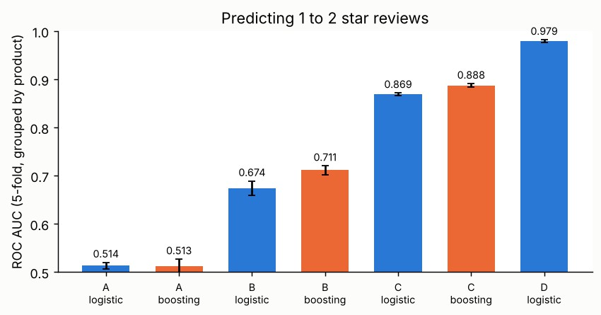
Figure 6. Cross-validated AUC by feature set (bars show fold-to-fold standard deviation)

How to read the result
- Engineered structured features help (A to B). AUC rises from 0.514 to 0.674 for logistic regression (+0.160) and from 0.513 to 0.711 for boosting (+0.199). The gains are many times larger than the fold-to-fold spread (about 0.01), so they are real. The raw set is at chance level (0.51) because product type alone cannot separate happy from unhappy customers.
- Text-derived features help most (B to C). AUC reaches 0.869 (logistic) and 0.888 (boosting) with a spread below 0.01. The largest coefficients are pos_count (−1.11 per SD), n_exclaim (−0.59) and negation_count (+0.43): enthusiastic, exclamatory reviews are rarely low-rated, and negations signal complaints.
- A plain bag-of-words is best (D). TF-IDF alone reaches 0.979. Hand-built features are therefore not about maximum accuracy; they are compact (47 columns instead of 20,000), interpretable, and tie directly to business questions. A final system should combine both.
- Caution. Sentiment features predict the rating partly because the text and the stars express the same opinion. Sets C and D measure how well words reproduce the rating. They do not

prove that a product will be liked. The more useful result for decisions is B: even without any text, product and customer features add real signal.

Hypothetical Business Scenario
Scenario (fictional): a skincare brand, "ClearLeaf", plans a range of cleansers, serums and a spot patch for acne-prone and sensitive skin. It must decide what to launch, how to word the packs, and where to place its customer-care effort. The table shows how EDA results and engineered features would shape each decision. The numbers come from the real Sephora sample used in this report.

Decision | Features used | Evidence (real data) | Action
Cleanser formula and complaint handling | flag_irrit, sens_x_nonpatch, act_* flags, fragranced | Irritation is 43.1% of low-rated facewash reviews; sensitive-mention reviews report it 34% of the time vs 13%; fragrance is not the driver (odds ratio 0.87), retinoid products are (22% vs  16%) | Do not rely on a "fragrance-free" claim alone; label active strength, add a patch-test and slow-start guide
How to launch the spot patch | flag_not_eff, type_patch, review text themes | 43.2% of low-rated patch reviews say it did not work; only 50% recommend | State clearly what the patch treats and how many days to use it; add before and after timelines
Whether to trust a product’s star average | price_z_in_type, log_product_reviews, rating vs recommend | Rating and recommendation agree (ρ = 0.70); only 145 conflicts in 140,435 reviews | Use recommend rate as a second quality metric
Early warning of a failing product | sentiment_score, neg_count, negation_count | Text features lift AUC from 0.71 to 0.89 | Score every new review; alert when a product’s low-rating share rises
Pricing positioning | price_z_in_type, price_tier | Serums average 78.18 USD, facewashes 29.21, yet ratings are equal (4.31 vs 4.31) | Higher price alone does not buy better ratings; price on benefits

Together, the features turn a star rating into a diagnosis: who is complaining, about what, and whether the cause is the formula, the claim or the use. That moves decisions from "this product is rated 3.0, fix it" to "this product is rated 3.0 because customers expected visible dark-spot fading and did not get it, so fix the claim and the instructions first".

Limitations and Next Steps
- One chunk of the data, one patch product. Two of the review files were analysed (reviews_500-750 and a name-filtered reviews_0-250); the Kaggle dataset has more. The only spot patch lies in reviews_500-750, so patch conclusions are about that one product. The remaining review files (250-500, 750-1250 and 1250-end) should be added to bring in more patch products.
- No labels. Reasons come from keyword rules (a third of low ratings fall under "other"), and the prediction target is the star rating. A hand-labelled sample of 600 to 1,000 low-rated reviews is needed.

- Missing fields. No "sensitive" skin type (H1; text mentions were used instead), and too few patch products for the re-ranking test (H5). Ingredient order and concentration are not available, so "has an active" cannot be told from "strong dose of the active".
- Multiple tests. Tests were pre-specified in Week 1; Benjamini-Hochberg correction will be applied when more are added. With n above 100,000, tiny effects become significant, so effect sizes (rank-biserial, Cramer’s V, odds ratios) are reported next to p-values.
- Associations only. Product type, price and brand are tangled; findings are not causal.
Next steps: (1) add the remaining review files (the product table is already joined) and rerun real_eda.py to bring in more patch products and test H1 and H5; (2) annotate a sample and replace the keyword rules; (3) fit text models (TF-IDF with logistic regression, then a transformer) on the labelled sample; (4) add the Google Trends and seasonal features of Section 5.3.

References

Methods and statistics
- Tukey, J. W. (1977). Exploratory Data Analysis. Addison-Wesley.
- Cohen, J. (1988). Statistical Power Analysis for the Behavioral Sciences (2nd ed.). Lawrence Erlbaum.
- Benjamini, Y., & Hochberg, Y. (1995). Controlling the false discovery rate: a practical and powerful approach to multiple testing. Journal of the Royal Statistical Society B, 57(1), 289–300.
- Efron, B., & Tibshirani, R. J. (1993). An Introduction to the Bootstrap. Chapman & Hall.

Feature engineering and leakage
- Kuhn, M., & Johnson, K. (2019). Feature Engineering and Selection: A Practical Approach for Predictive Models. CRC Press.
- Zheng, A., & Casari, A. (2018). Feature Engineering for Machine Learning. O’Reilly Media.
- Micci-Barreca, D. (2001). A preprocessing scheme for high-cardinality categorical attributes in classification and prediction problems. ACM SIGKDD Explorations, 3(1), 27–32.
- Kaufman, S., Rosset, S., Perlich, C., & Stitelman, O. (2012). Leakage in data mining: formulation, detection, and avoidance. ACM Transactions on Knowledge Discovery from Data, 6(4), 1–21.

Software
- Pedregosa, F., et al. (2011). Scikit-learn: machine learning in Python. Journal of Machine Learning Research, 12, 2825–2830.
- McKinney, W. (2010). Data structures for statistical computing in Python. Proceedings of the 9th Python in Science Conference, 56–61.
- Virtanen, P., et al. (2020). SciPy 1.0: fundamental algorithms for scientific computing in Python. Nature Methods, 17, 261–272.
- Hunter, J. D. (2007). Matplotlib: a 2D graphics environment. Computing in Science & Engineering, 9(3), 90–95.

- Waskom, M. L. (2021). seaborn: statistical data visualization. Journal of Open Source Software, 6(60), 3021.

Text analysis and skincare reviews
- Liu, B. (2012). Sentiment Analysis and Opinion Mining. Morgan & Claypool.
- Hutto, C. J., & Gilbert, E. (2014). VADER: a parsimonious rule-based model for sentiment analysis of social media text. Proceedings of ICWSM.
- Putri, R. S., Randika, R. P., Sasmita, F. D., & Subarkah, P. Sentiment analysis of skincare product reviews: a comparison of Naive Bayes and Support Vector Machine algorithms. JAIC, 10(4). doi:10.30871/jaic.v10i4.13227
- Alifi, A., & Yustanti, W. (2026). Sentiment analysis and word association patterns in skincare product customer reviews. JEISBI, 7(2). doi:10.26740/jeisbi.v7i2.76813

Data
- Sephora Products and Skincare Reviews (Kaggle dataset by nadyinky), files reviews_500-750.csv and product_info.csv, accessed 1 November 2026.

Appendix: Synthetic-data check, files and environment
The Week 3 pipeline was built on simulated reviews with a known answer key. The same feature comparison on that data (Week 4 first run) gave cross-validated AUC of 0.686 (set A) and 0.678 (set B) for logistic regression, no reliable gain, because the simulator’s side-effect risk depended almost entirely on fragrance, which both sets contained. On real data, set B beats set A by +0.16 to +0.20. The contrast shows why the project needed real reviews: effects built into a simulator are not the effects customers write about. The synthetic-data code and results remain in the repository as a method check.

File | Purpose
real_eda.py | All analyses, tests, features, model comparison and figures in this report (real data)
reviews_500-750.csv, product_info.csv | Inputs: Sephora reviews and product table (public Kaggle data; not re-uploaded)
real_features.csv | Output: 49 engineered features for each of 140,435 reviews, with train/test split
real_results.json | Every number quoted in this report
eda_features.py, eda_results.json | Earlier run on the synthetic Week 3 data (method check)

To reproduce: put reviews_500-750.csv and product_info.csv next to real_eda.py and run python real_eda.py (pandas, NumPy, SciPy, scikit-learn, matplotlib, seaborn). Environment: Python 3.13, pandas 3.0.5, NumPy 2.5.3, scikit-learn 1.9.1, SciPy 1.18.1. Random seed 42. This document analyses public customer reviews and is not medical advice.

